2021.03.08

Kazuhiro Hotta

**Automated optical Characterization setup**

**Operation manual (rev. 0.0)**

**Contents**

**Precautions 3**

**1. Overview of the system 4**

1-1. Hardware 4

1-2. Software8

**2. Procedures to execute the standard measurement workflow 9**

2-1. Scripts and standard workflow 9

2-2. System Power on 10

2-3. Turn on light sources 13

2-4. Remove solvent from the dilution and collection vials 13

2-5. Execute the measurements 13

2-5-1. Manual measurements14

2-5-2. Automated measurements (with HPLC-MS)16

2-6. System shutdown 17

2-7. The result viewer18

**3. Detail of the measurements 20**

3-1. UV-vis absorption 20

3-2. Photoluminescence 22

3-3. PL lifetime 25

3-4. Calculations for the laser molecules 28

3-5. Solvent reformatting29

**4. Advanced usage 31**

4-1. Developing a new workflow 31

4-2. Changing the configuration 32

4-3. Addition of new setups 33

**5. Maintenance 34**

5-1. Calibration of the spectrometer 34

5-2. System washing 35

**6. Appendix 36**

6-1. Parts list 36

6-2. Trouble shooting 40

6-3. Future extensions 40

**Precautions**

* Read this manual carefully before starting to use the system.
* The user of the system **must take the Laser safety training** (EHS737 and EHS738) before using the system.
* The system has the harmful ultraviolet (UV) light sources including the 365 nm LED for the photoluminescence (PL) measurement and the 375 nm pico-second pulse laser (max. 4 mW) for the PL lifetime measurement. They are fully enclosed as long as the system is used along with the standard measurement procedures, however, **wear the appropriate PPE** (lab coat, laser googles…) when using them in the open space. To use the laser in the open space, you **must turn the laser sign on two of the entrance doors of the lab to “Laser on”** and **ask other people in the lab to wear the laser googles**.
* The system is developed in-house, and we should take advantages of the flexibility of such a system, however, please be careful when you modify the system as it affects the data consistency especially when the system is used by several different person or in different projects. I will recommend keeping a usage log in such situations.

**1. Overview of the system**

**1-1. Hardware**

The optical characterization setup described in this manual is the part of the end-to-end automated experimental platform comprising an automated synthesis platform (Chemspeed), an identification/purification platform (HPLC-MS) and an optical characterization flatform. These platforms are physically connected via solution transfer tubings so that the sample can be transferred without manual operations. All the platforms can be controlled by the scripts written in python and communicate each other based on the file exchange via Dropbox.

The characterization setup is designed to work within the workflow especially for the discovery of new materials, i.e., the sensitivity and the robustness is the priority of the setup design so that the characterization can be done even when the reaction yield is low.

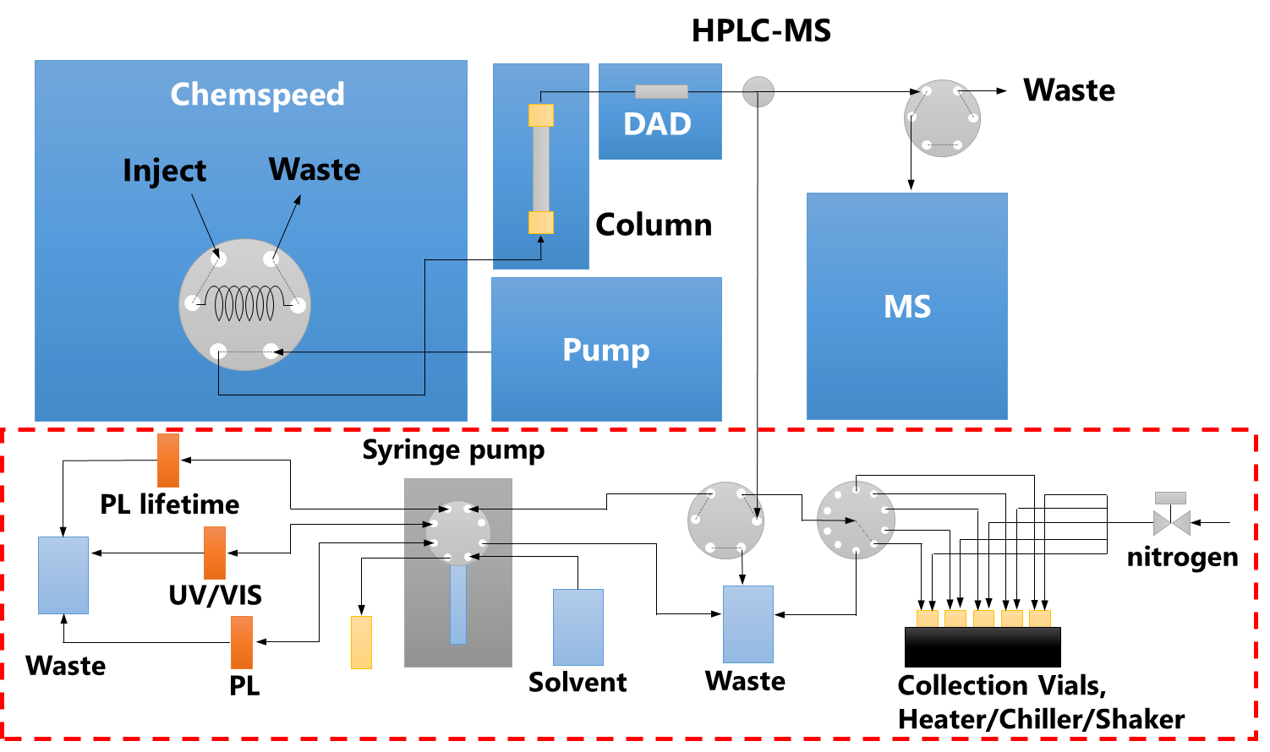

**Figure 1.** Schematic diagram of the whole system. In this manual is mainly for the characterization setup in the red box.

Figure 2 shows the detailed connection diagram of the characterization setup. The purified sample from the HPLC-MS is first collected selectively in the collection vials based on the retention time-based switching of the flow selector and then transferred to the measurement flow cells by using the syringe pump. At present, the UV-vis absorption, the photo luminescence (PL) emission and PL lifetime setups are connected to the system and optical properties such as UV-vis absorption and PL emission spectra, PL quantum yield (PLQY), PL lifetime and photodegradation rate can be evaluated. These setups are parallelly connected to the syringe pump, and this configuration make it possible to dilute the sample between the different measurements to adjust the amount or the concentration of the sample, or to change the solvent by evaporation and redissolution by using the heater/chiller/shaker unit.

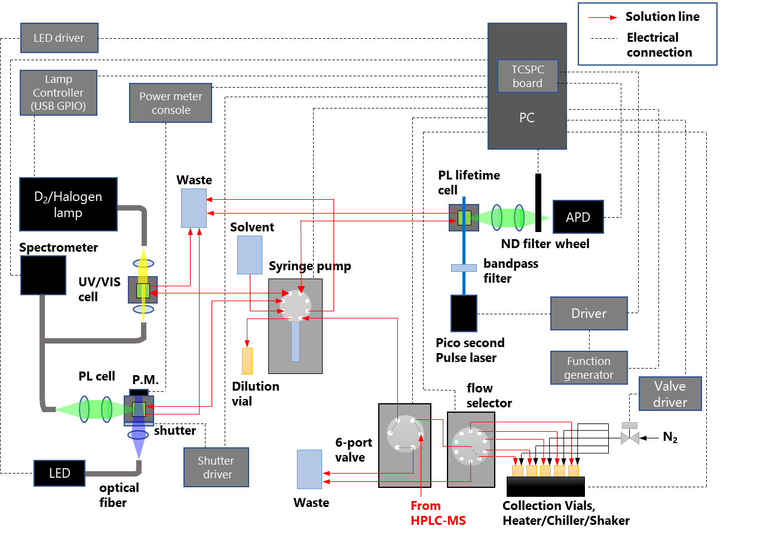

**Figure 2.** Detailed diagram of the optical characterization part.

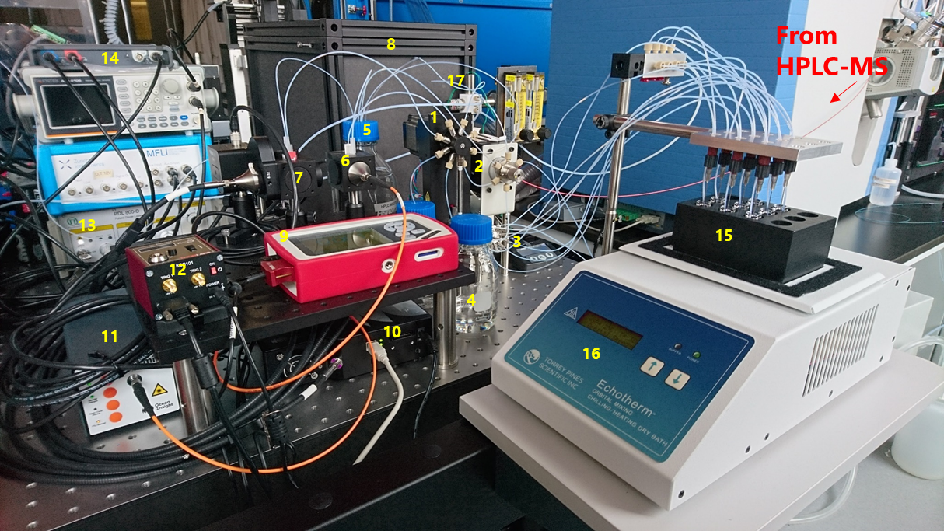

**Figure 3.** A picture of the system (on the optical table). 1: Syringe pump, 2: 6-port valve, 3: flow splitter, 4: solvent bottle, 5: waste bottle, 6: UV/VIS absorption cell, 7: PL cell, 8: PL lifetime setup, 9: power meter, 10: spectrometer, 11: D2/Halogen lamp, 12: shutter driver, 13: pico-second laser driver, 14: oscilloscope/function generator, 15: collection vials, 16: shaker/heater/chiller, 17: solenoid valve (N2)

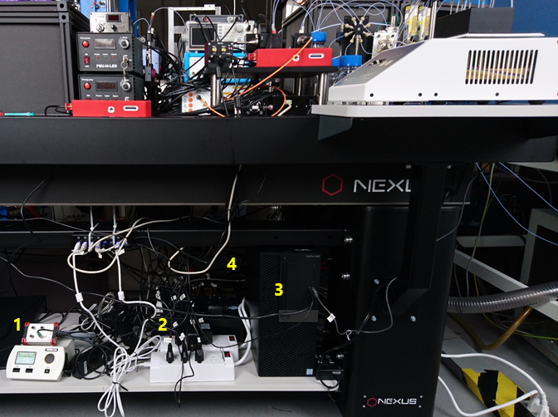

**Figure 4.** A picture of the system (under the optical table). 1: LED driver, 2: USB power bar, 3: PC, 4: solenoid valve driver

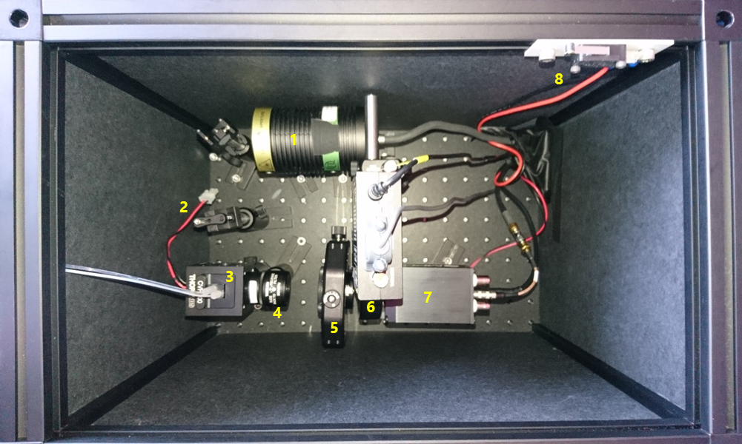

**Figure 5**. A picture the system (inside the enclosure for the PL lifetime setup) 1: pulse laser, 2: band pass filter, 3: flow cell, 4: lens, 5: lens, 6: ND filter wheel, 7: Avalanche photo diode, 8: interlock switch

**1-2. Software**

As described in the previous section, all the devices in the system as well as the experimental workflow can be controlled by the python scripts. You can find these python scripts in the Dropbox folders.

* **The low-level APIs to control each component of the setup.**

-> *Dropbox/PythonLab/pylab/instruments*

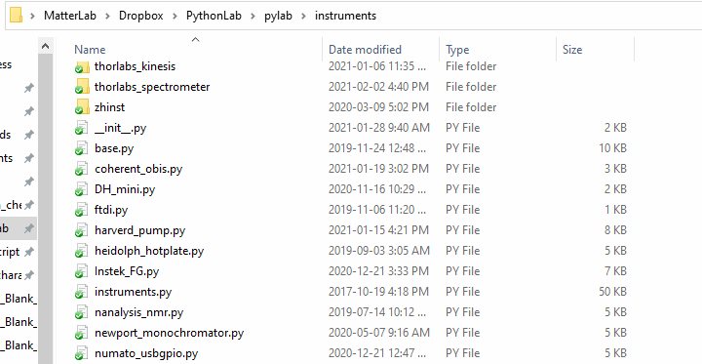

**Figure 6.** *Dropbox/PythonLab/pylab/instruments* folder.

* **The high-level APIs to control experimental workflow.**

-> *Dropbox/PythonScript/kazu/optical_characterizations*

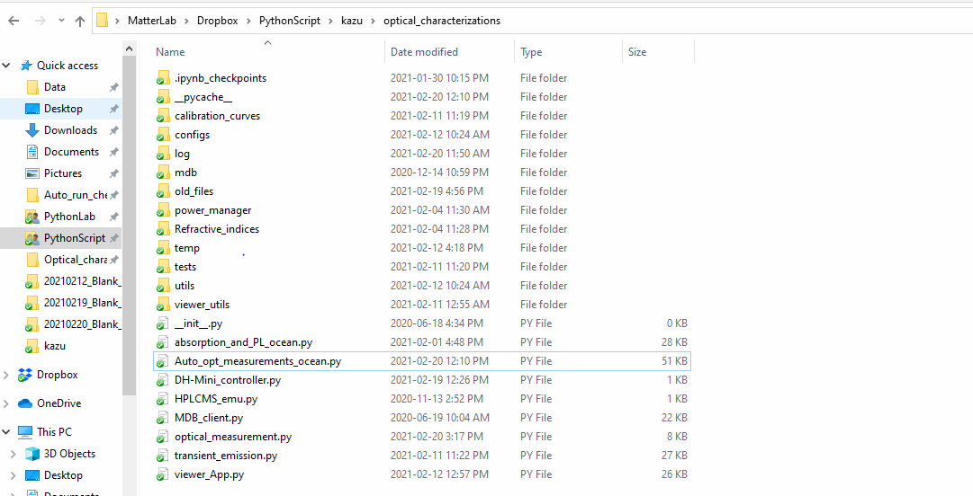

**Figure 7.** *Dropbox/PythonScript/kazu/optical_characterizations*folder.

**2. Procedures to execute the standard measurement workflow**

**2-1. Scripts and standard workflow**

In this section, the procedures to execute the optical measurements through the standard workflow predefined in the python scripts are described.

The workflow and the experimental parameters are defined in the following files.

**1. The codes for the standard workflow.**

*Dropbox/PythonScript/kazu/optical_characterizaitons/Auto_opt_measurements_ocean.py*

**2. The codes for the experimental parameters.**

*Dropbox/PythonScript/kazu/optical_characterizaitons/configs/* *config_AutoOpt_ocean.py*

You can see how to use these scripts with the example codes in the following file.

**3. The example codes to execute the workflow.**

*Dropbox/PythonScript/kazu/optical_characterizaitons/optical_measurement.py*

The workflow functions are defined in the *Optical_measurement*s class in the */Auto_opt_measurements_ocean.py.*

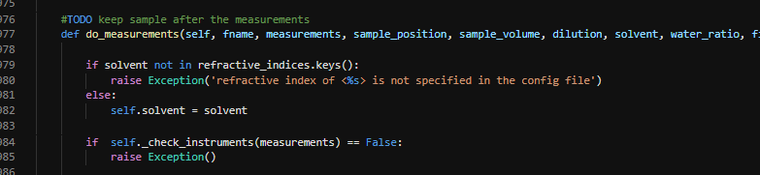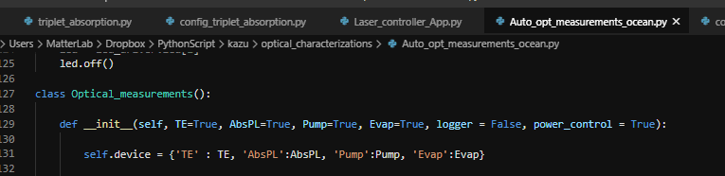

So, you need to create the script to use this class (see example code 3.) and run it with the command line processor (like Git bash, next page) to carry out the measurement.

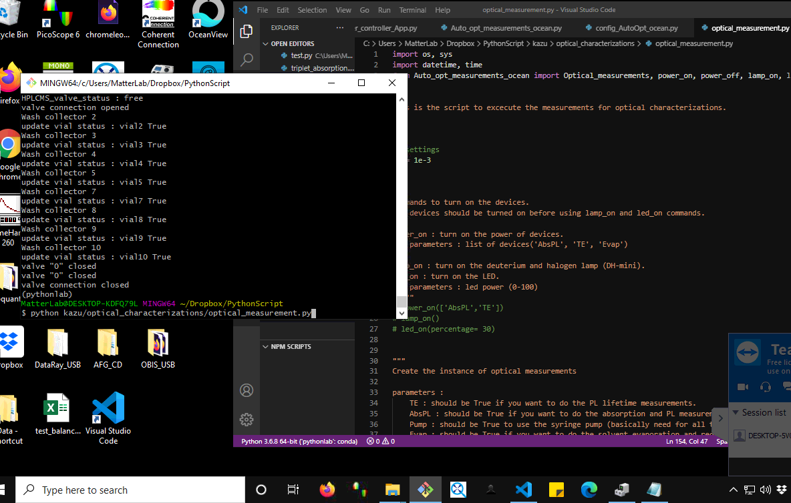

Git bash to run python scripts

VS code to edit the scripts

The measurements are carried out following the workflow shown below.

Collect sample from collector vials and send it to dilution vial.

If next measurement

Do dilution (if necessary).

Measure reference with the solvent.

Send a sample to the flow cell and do measurement.

Collect sample from the flow cell to dilution vial.

Discard the sample to the waste and wash the system.

**Figure 8.** The standard measurement workflow.

**2-2 System power on**

The first thing you need to do is to turn on the power of the devices in the systems. The devices necessary for the measurement depends on what type of measurements you do and are listed in the table 1.

|  |  |  |  |
| --- | --- | --- | --- |
| Experiment | Device | remote |  |
| Absorption/  PL | DH-mini  (D2/Halogen lamp) | x |  |
| LED driver | x |  |
| Shutter driver | x |  |
| Spectrometer  (power plug) | x |  |
| Power meter console | x |  |
| PL lifetime | Laser driver  (power and  turn key) | x |  |
| Function generator |  | USB cable (always on) |
| Avalanche photodiode | x |  |
| ND filter wheel |  | Power plug (always on) |
| Redissolution | Heater/  Chiller/  Shaker | x |  |
| All | Syringe pump |  | Power plug (always on) |
| 6-port valve |  | Power plug (always on) |
| Flow selector |  | Power plug (always on) |

**Table 1.** The list of the power switches/plugs of the setup.

The devices in the table 1 with x in the “remote” column are connected to USB-controlled power bar (Figure 9). This allows you to turn on/off the power without using the physical switches. So, you can control them remotely if you have a remote access to the computer.

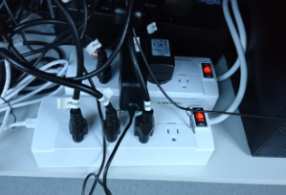

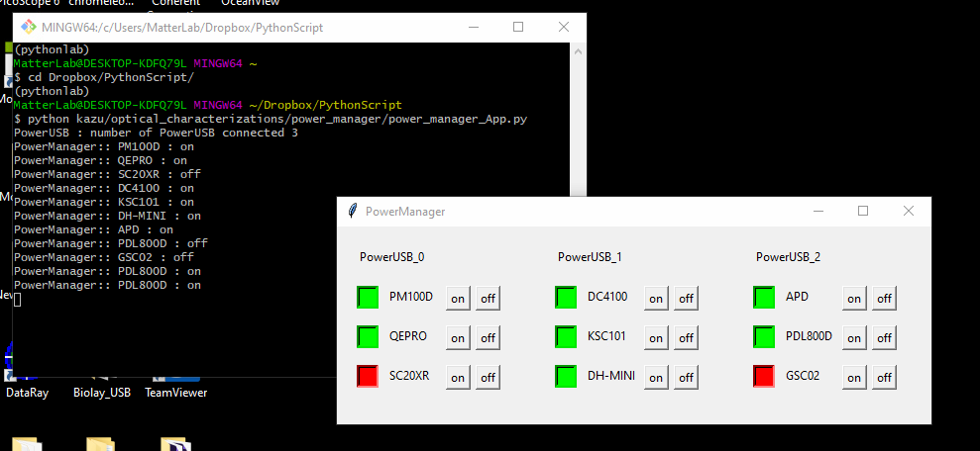

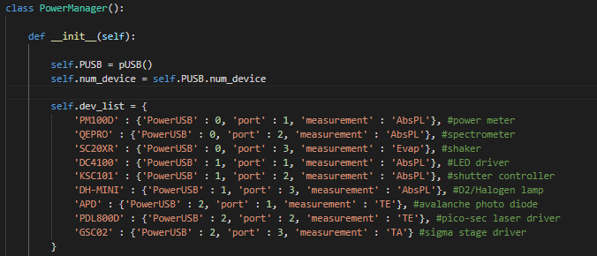

**Figure 9.** (Top)The USB-controlled power bars. (Middle)The control application and (Bottom) configuration file.

These power bar can be controlled by either of the following three ways.

1) using the *optical_characterizaitons/power_manager/power_manager_App.py* (middle)

2) using the power_on/power_off commands in *Auto_opt_measurements_ocean.py*

3) creating the instance of *Optical_measurements* class with *power_controll = True.*

(the class is in the *Auto_opt_measurements_ocean.py*)

You can change the power bar configuration by modifying the device list in the *optical_characterizaitons/power_manager/power_manager.py*. (Bottom image).

**2-3. Turn on light sources**

For the absorption and PL measurements, we need to turn on D2/Halogen lamp and LED as light sources. These can be turn on either by using lamp_on/led_on commands in the *Auto_opt_measurements_ocean.py* or by creating the instance of *Optical_measurements* class (also in the *Auto_opt_measurements_ocean.py*) with *AbsPL = True*.

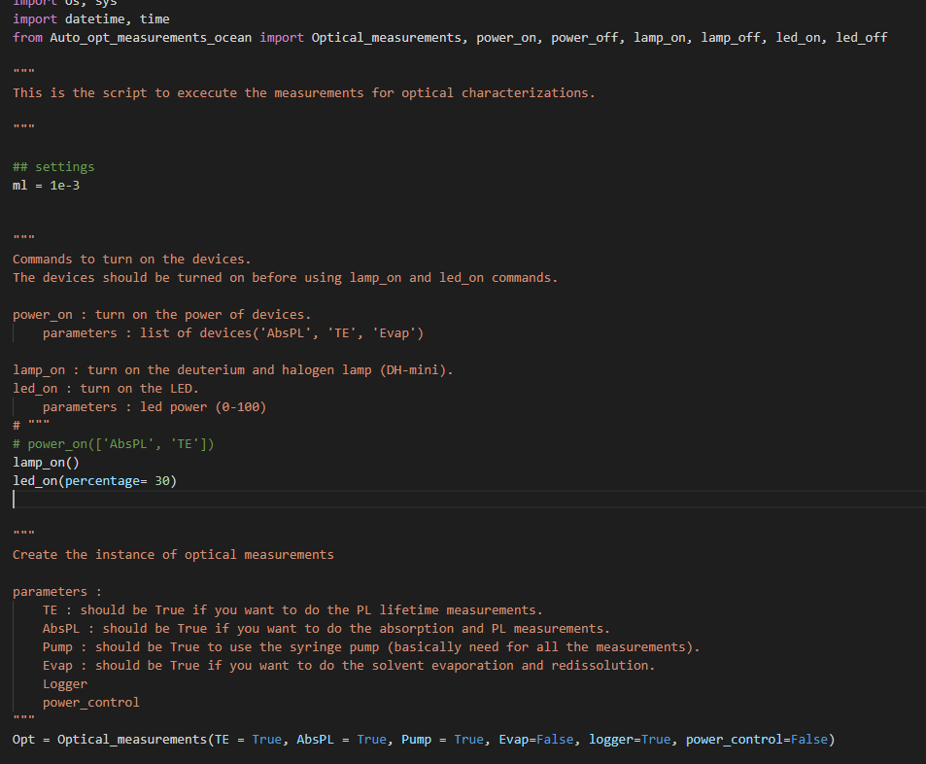



**or**



**Figure 10.** The commands to turn on the light sources.

The light sources as well as the spectrometer* need some time before they get stable after they are turned on. The stabilization times for each device are roughly as follows.

|  |  |
| --- | --- |
| D2/Halogen lamp | 20 min |
| LED | 20 min |
| Spectrometer | 30 min |

**Table 2.** Stabilization time for the light sources and the spectrometer.

*spectrometer is automatically turn on when you turn on the power.

**2-4. Remove solvent from the dilution and collection vials**

The dilution vial and collection vials might be filled with the solvent after the previous experiments for the washing purpose. In that case, you need to remove them before your measurements by using the washing commands with *repeat =* 0 and *fill = False*.



**2-5. Execute the measurements**

You can do the measurements both for the samples prepared manually or that come out from the HPLC-MS. The procedures for manually prepared samples are described in the section 2-5-1. Proceed to the section 2-5-2. if you want to do the measurements with HPLC-MS.

**2-5-1. Manual measurements**

* **Sample loading**

The sample for the measurement can be loaded either in the dilution vial or in the collection vials (Fig. 11). You should specify the vial you put the sample in the script (p. 15). The minimum amount of sample necessary for the measurements are shown in Table 3. The system will automatically add solvent if the sample is less than the minimum.

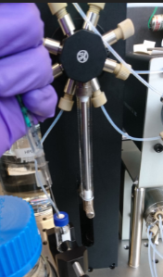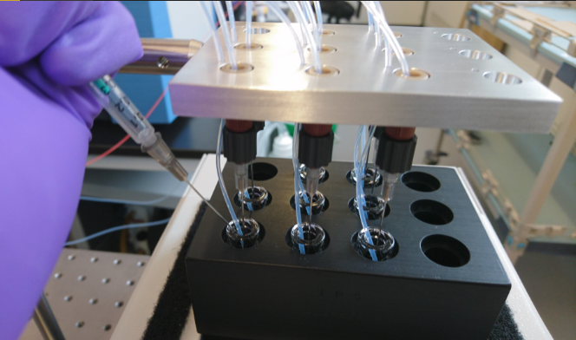

**Dilution vial**

**Collection vials**

**Figure 11.** Sample loading to the dilution vials and collection vials.

|  |  |
| --- | --- |
| UV-vis absorption | 90 mL |
| Photo luminescence | 110 mL |
| PL lifetime | 110 mL |

**Table 3.** The minimum amount of sample necessary for the measurements.

* **Measurements**

Once you load your sample, you can execute the measurements by using the python scripts. The standard workflows of the optical measurements are defined as the functions of the *Optical_measurements* class. So, you first need to create the instance of the class to execute the measurement



.

**Parameters:**

* **TE**: Should be true if you do the PL lifetime measurement.
* **AbsPL**: Should be true if you do the UV/VIS absorption and/or PL measurements.
* **Pump**: Should be true if you use syringe pump for the sample transfer.
* **Evap**: Should be true if you use heater/chiller/shaker unit for the solvent reformat.
* **logger**: log the system operation in a text file if True.
* **power_control**: turn on power of the devices necessary for the measurements if True.

Then, the standard measurement workflow can be initiated and completed by using the “*do_measurements*” command. The measurement parameters for each measurement are specified in “*configs/* *config_AutoOpt_ocean.py*”. Please refer Section 3 for the details of the parameters.

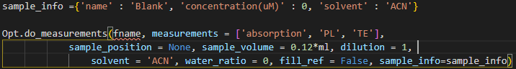

**Parameters:**

* **fname**: filename used to save the results.
* **measurements**: list of the measurements you carry out ('absorption', 'PL', 'TE').
* **sample_position**: collection vial number where your sample is located (2,3,4,5,7,8,9,10). If you put the sample in the dilution vial, please specify *None*.
* **sample_volume**: volume of the sample (e.g., 0.2*ml)
* **dilution**: the degree of dilution the system will do before the measurements.

(If you set 2, the setup makes 2 times dilution. set 1 if you will not do dilution.)

* **solvent\***: solvent used for the measurements. This is used to calculate the PLQY using its refractive index.
* **water_ratio\*\***: adjust the water ratio of the reference solvents. Set 0 if the sample solution does not contain water.
* **fill_ref\*\*\***: send solvent to the flow cells before the measurement if True.
* **sample_info**: dictionary of sample information for record.

*Currently we have 'ACN', 'toluene' 'Ethanol' in the list. Add it to the list in "config_AutoOpt_ocean.py" if you want to use the new solvent.

**This would be useful when the sample comes out from the HPLC-MS with some amount of water, but currently the system **is not** connected to the water bottle. So always set it as 0.

***The standard workflow ends up with the flow cells filled with the solvent. So, it usually does not necessary to do this before the measurements.

* **Results of the measurements**

After all the measurements are done, the following experimental result files are output in the folder specified in the *fname.*

* **csv file**: numerical data in csv format.
* **png file**: image of the result graphs.
* **pkl file**: contains all the information of the measurement.

(You can open it with the viewer application. See section 2-5.)

**2-5-2. Automated measurements (with HPLC-MS)**

This system is possible to automatically carry out the measurements for the sample coming out of the HPLC-MS. In this mode, the measurements are initiated by the job file input from the HPLC-MS, by which the information necessary for the measurements (sample volume, location, optical absorption properties, etc….) are transferred.

To execute the measurements in this mode, first we need to create the instance of the *Optical_measurements* class (see section 2-3-1 for the details) and use the “auto_measurement” command to turn the system to job waiting state.

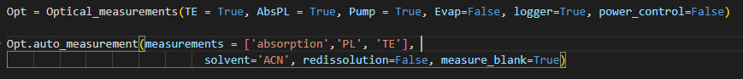

**Parameters:**

* **measurements**: list of the measurements you carry out ('absorption', 'PL', 'TE').
* **Solvent\***: solvent used for the measurements. This is used to calculate the PLQY using its refractive index.
* **redissolution**: do sample evaporation and redissolution if True. Parameters are specified in "config_AutoOpt_ocean.py".
* **measure_blank**: do blank measurements before waiting the job input, if True

*Currently we have 'ACN', 'toluene' 'Ethanol' in the list. Add it to the list in "config_AutoOpt_ocean.py", if you want to use the new solvent.

In the job waiting state, the system monitors the *job_input* folder specified in the “*configs/* *config_AutoOpt_ocean.py*” (see below) and initiate the measurements once it finds the job file in the folder.

After the measurements, the result files are output in the *result_output* folder and the system go back to the job waiting state for the next measurements.

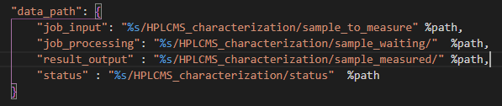

The input job file contains following information.

* **injection_name**: The name of the HPLC-MS injection.
* **target_name**: The name of the target compound.
* **target_smiles**: The smiles of the target compound (optional).
* **retention_time**: The retention time of the target compound.
* **vial_number**: The position of the vial where the target compound is collected.
* **average_absorbance_peak**: The absorbance of at the absorption maximum.
* **average_absorbance_375**: The absorbance at the 375 nm (excitation wavelength).
* **sample_volume**: sample volume in mL.

**2-6. System shutdown**

After the measurements, the system is already washed with the solvent*. So, it’s ready to shut down when all of your measurements are done. The system can be shutdown by using the following commands.

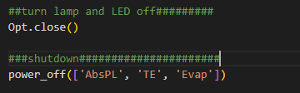

* Opt.close: Turn lamps and LEDs off.
* power_off: Turn off the power of the devices.

**Parameters:**

* **measurements:** list of the devices to be power-off (‘AbsPL’, ‘TE’, ‘Evap’).

*The flow cells are filled with the solvent and the dilution vial and the collection vials are left empty after the washing.

**2-7. The result viewer**

The standard measurement workflow generates the three types of results files as described before (png, csv, and pkl files). Among them, the pkl files contains all the information relating to the measurements and can be read by using the viewer application.

“*Dropbox/PythonScript/kazu/optical_characterizaitons/* *viewer_App.py.*”

The current version is intended to be used for the laser molecules but might be useful for other type of applications.

When you run the script of the viewer, the following window will appear. You can choose the result files to be read by clicking *File -> Open* on the window.

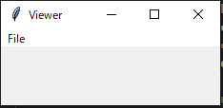

Figure 12 shows the main window of the viewer. You can see some graphs and values obtained in the measurements in this window. The experimental parameters and job info for the measurement can be checked by *File_info -> measurement_info* and *File_info -> job,* respectively*.*

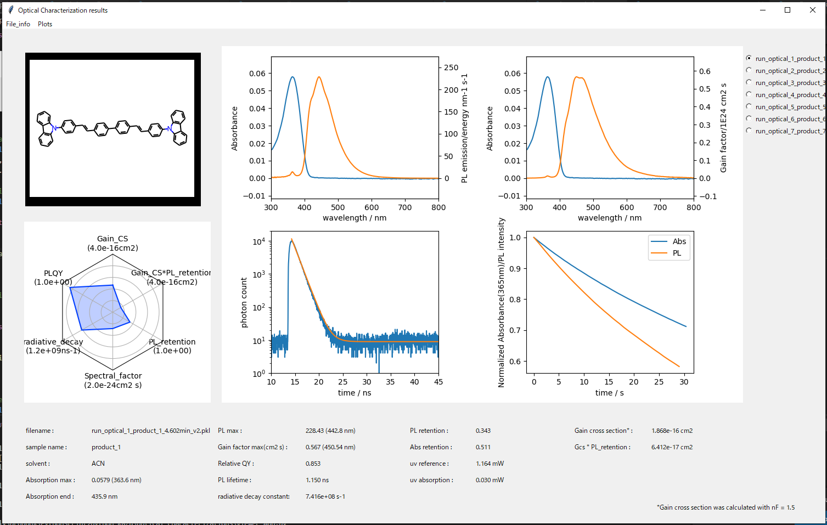

**Figure 12.** The main window of the viewer application.

You can also generate the heat map and scatter plot of the target properties for the laser molecules by *Plots-> Heat map* and *Plots-> Scatter plots*, respectively.

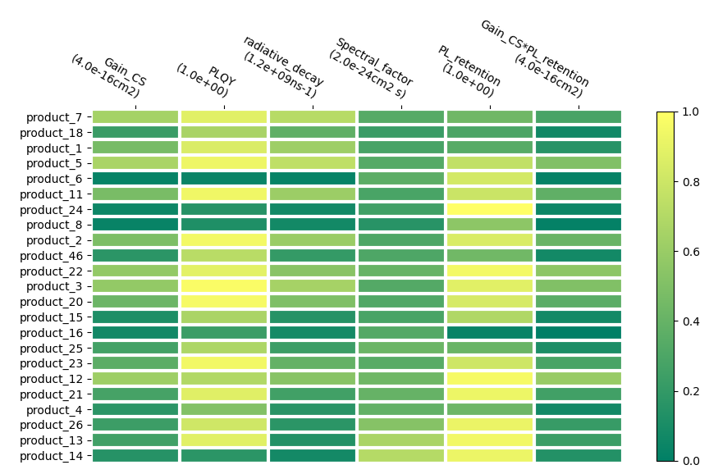

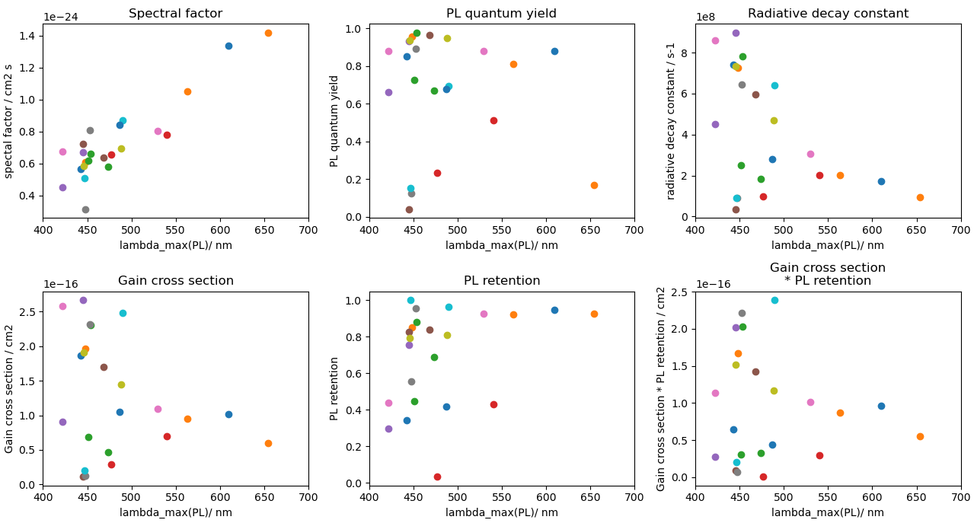

**Figure 13.** (top) The heat map and (bottom) the scatter plot of the measurement results.

**3. Detail of the measurements**

**3-1. UV-vis absorption**

The UV-vis absorption spectrum of the sample can be measured by specifying the ‘absorption’ in the measurements list of the measurement commands.



The measurement is done along with the following workflow and the absorption spectrum is calculated from the transmission spectra for the refence (blank) and the sample solutions.

Send solvent to the flow cell as a reference.

(if the cell is not filled with it*)

Do dilution (if necessary).

1. Add solvent to the sample in the dilution vial.
2. Mix them by drawing and dispensing by the pump.

Measure reference with the solvent.

1. Dark spectrum with shutter closed
2. Reference spectrum with shutter opened

Send a sample to the flow cell

1. Send the air to the flow cell to make the cell empty.
2. Send the sample to the cell.
3. Wait sometime for stabilization.

Do measurement.

1. Dark spectrum with shutter closed
2. Transmission spectrum with shutter opened

Collect sample from the cell to the dilution vial

**Figure 14.** The standard UV-vis absorption measurement workflow.

*The standard workflow ends up with the flow cells filled with the solvent.

So, it usually doesn’t necessary to do this before the measurements.

**Parameters for the absorption measurement**

The measurement parameters of the absorption measurements are specified in the

*optical_characterizaitons/configs/* *config_AutoOpt_ocean.py*

You can change them by modifying the values in the file.

* **abs_minimum_volume**:the minimum amount of the sample necessary for the measurement.
* **abs_maximum_absorption**:maximum absorbance of the sample. The system will do dilution if absorbance at peak is larger than this value (only for the auto-measurement with HPLC-MS).
* **abs_equibliration_time**: stabilization time before the measurement (in seconds).
* **abs_exposure**:exposure time (in seconds).
* **dark_average**:number of dark spectra recorded and used for averaging.
* **abs_average**:number of transmission spectra recorded and used for averaging.
* **abs_draw_velocity**:pump velocity to draw the sample from the vial.
* **abs_dispense_velocity**:pump velocity to dispense the sample to the cell.
* **abs_do_plot**:show absorption spectrum after the measurement if True.
* **abs_calc_range**:spectral range used for the calculation.

**Calculations**

The absorption spectrum is calculated from the collected spectra using the following equation.

$$A\left(λ\right)=-\log_{10}\left(\frac{I_{sample}\left(λ\right)-I_{sample,dark}\left(λ\right)}{I_{ref}\left(λ\right)-I_{ref,dark}\left(λ\right)}\right)$$

*I*: measured light intensity

**3-2. Photoluminescence**

The photoluminescence spectrum (PL) and related properties of the sample can be measured by specifying the ‘PL’ in the measurements list of the measurement commands.



The measurement is done along with the following workflow and the PL spectrum is calculated from the emission spectrum and the spectral response function of the system. The absorption of the excitation light is also recorded simultaneously, so the relative PL quantum yield can be evaluated.

Send solvent to the flow cell as a reference.

(if the cell is not filled with it*)

Do dilution (if necessary).

1. Add solvent to the sample in the dilution vial.
2. Mix them by drawing and dispensing by the pump.

Measure LED transmission with the solvent (reference).

Send a sample to the flow cell

1. Send the air to the flow cell to make the cell empty.
2. Send the sample to the cell.
3. Wait sometime for stabilization.

Do measurement.

1. Adjust exposure time not to exceed the saturation level of the spectrometer.
2. Measure dark spectrum with shutter closed.
3. Measure emission spectrum and LED transmission with shutter open.

Collect sample from the cell to the dilution vial

**Figure 15.** The standard PL measurement workflow.

*The standard workflow ends up with the flow cells filled with the solvent.

So, it usually doesn’t necessary to do this before the measurements.

**Parameters for the photoluminescence measurement**

The measurement parameters of the PL measurements are specified in the

*optical_characterizaitons/configs/* *config_AutoOpt_ocean.py*

You can change them by modifying the values in the file.

* **PL_minimum_volume**: the minimum amount of the sample for the measurement.
* **PL_equibliration_time**: stabilization time before the measurement (in seconds).
* **led_power**: power of the LED used for the measurement (0 to 100).
* **PL_average**: number of PL spectra recorded.
* **PL_max_exposure**: the maximum exposure time (in seconds).
* **PL_min_measurement_time**: the minimum PL measurement time to record the time trace of the UV absorption and PL spectrum.
* **PL_initial_exposure**: the initial exposure time when adjusting the exposure time.
* **PL_target_intensity**: the target PL intensity when adjusting the exposure time.
* **uv_average**: number of LED transmission power recorded (only used for the reference).
* **PL_draw_velocity**: pump velocity to draw the sample from the vial.
* **PL_dispense_velocity**: pump velocity to dispense the sample to the cell.
* **PL_calc_range**: spectral range used for the calculation.
* **PL_cutoff**: the relative peak intensity above which the calculation is done (0 to 1).

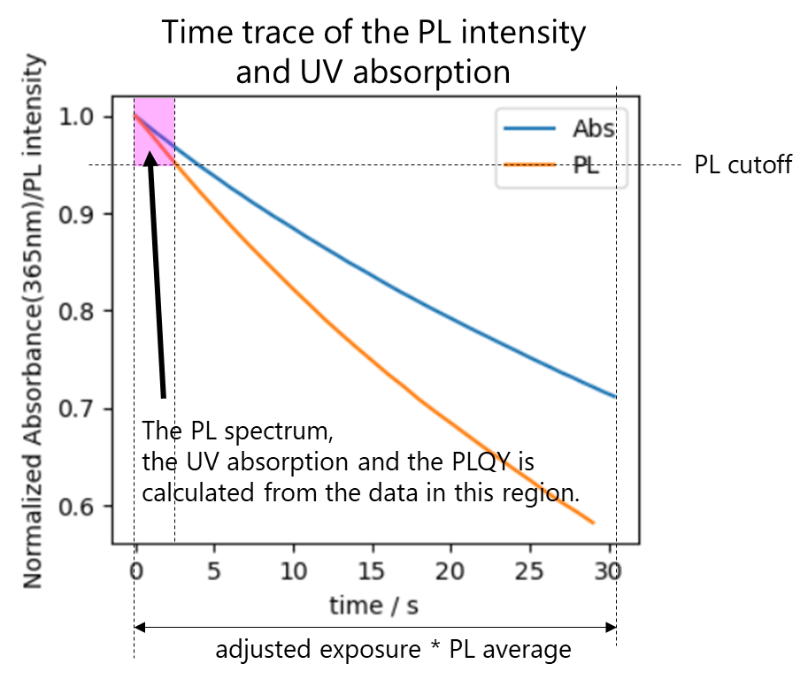

**Figure 16.** The time-trace data of the PL intensity and the UV absorption.

**Calculations**

The photoluminescence spectra and the quantum yield are calculated based on the following equations using the spectral response function (calibration curve) of the setup.

* **The PL spectrum (photon unit)**

$${PL}_{photon}\left(λ\right)=\frac{\left(I_{sample}\left(λ\right)-I_{sample,dark}\left(λ\right)\right)}{Response function \left(λ\right)*exposure}$$

*I*: measured light intensity

* **The PL spectrum (Energy unit)**
$${PL}_{energy}\left(λ\right)={PL}_{photon}\left(λ\right) / λ$$

* **The relative quantum yield**

$${PLQY}_{relative}={PLQY}_{ref}\frac{\sum_{λ}{{PL}_{photon}\left(λ\right)Δλ}}{\sum_{λ}{{PL}_{photon,ref}\left(λ\right)Δλ}}*\frac{f_{ref}}{f}*{\left(\frac{n_{solvent}}{n_{solvent,ref}}\right)}^{2}$$

*f*: absorptance, *n*: refractive index

Changes in the PL intensity and the UV absorption due to the photodegradation are often observed during the measurement as shown in Figure 16. This is remarkable especially when the sample solution is measured without removing oxygen by, for example, N2­ or Ar bubbling. Even though the compounds might be used under the inert condition, the measurement could be used as a kind of accelerated degradation test. As the measurement time varies depends on the exposure time, the PL intensity and UV absorption retention is estimated at 1 min by assuming the first-order degradation*.

* **The PL and UV retention (at 1 min)**

$$retention \left(1 min\right)={\left(retention(t_{e})\right) }^{1/t_{e}}$$

*te*: measurement duration (in minutes)

*This does not accurately describe the degradation phenomenon, however, is used here for the simplicity since it is not possible to find the general description applicable to any type of molecules.

**3-3. PL lifetime**

The PL lifetime of the sample can be measured by specifying the ‘TE’ in the measurements list of the measurement commands.



The measurement is done along with the following workflow and the PL lifetime is evaluated based on the method called “Time correlated single photon counting (TCSPC)”. In brief, the TCSPC electronics records the time difference between the excitation pulse and the photon emitted from the sample and obtains the PL decay curve by collecting the data on millions of the photons. On that note, it is important to keep the photon detection rate **less than 1 to 5%** for the excitation rate to prevent the pile up of photon detection*. The system automatically adjusts this by using the ND filter wheel according to the setting, as well as the excitation frequency. The PL decay curve is then fitted against the single or double exponential function, by which the PL lifetime of the sample is estimated.

Do dilution (if necessary).

1. Add solvent to the sample in the dilution vial.
2. Mix them by drawing and dispensing by the pump.

Send a sample to the flow cell.

1. Send the air to the flow cell to make the cell empty.
2. Send the sample to the cell.
3. Wait sometime for stabilization.

Do measurement.

1. Adjust detection efficiency using the ND filter wheel.
2. Adjust excitation pulse frequency using the function generator.
3. Measure PL decay curve.

Collect sample from the cell to the dilution vial.

**Figure 17.** The standard PL lifetime measurement workflow.

* *https://www.picoquant.com/images/uploads/page/files/7253/technote_tcspc.pdf*

To measure the PL lifetime with this workflow, the trigger input of the laser driver should be connected the generator output via a BNC cable and the trigger mode should be “External” (Figure 18).

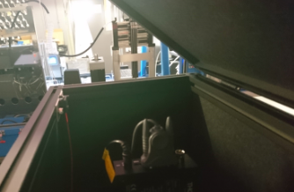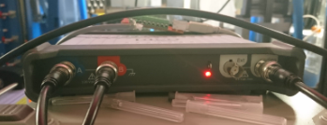

**Limit switch**

**(interlock)**

**Generator output**

**External mode**

**Trigger input**

**Figure 18.** The function generator and the laser driver

The enclosure of the setup has the limit switch for the interlock (Fig 18. Top-right. The laser emits only when the enclosure is closed.). If the laser does not emit even when the enclosure is closed, please check the limit switch works properly.

Please see the reference* and the driver manual** for the detail of the measurements.

**Parameters for the PL lifetime measurement**

\**https://www.picoquant.com/images/uploads/page/files/7253/technote_tcspc.pdf*

\*\**Dropbox/PythonLab/manuals/PDL800D/ PDL800D_manual.pdf*

The measurement parameters of the PL lifetime measurements are specified in the

*optical_characterizaitons/configs/* *config_AutoOpt_ocean.py*

You can change them by modifying the values in the file.

* **TE_minimum_volume**: the minimum amount of the sample for the measurement.
* **TE_draw_velocity**: pump velocity to draw the sample from the vial.
* **TE_dispense_velocity**: pump velocity to dispense the sample to the cell.
* **min_rate**: the minimum ratio of the photon detection rate and the excitation rate. The measurement is skipped when the detection rate doesn’t reach this value.
* **max_rate**: the maximum ratio of the photon detection rate and the excitation rate. The measurement is done with the ND filter position which allows maximum detection rate below this value.
* **accumulation**: data collection continues until the photon count (peak) reaches this value.
* **initial_frequency**: initial excitation frequency for adjustment.
* **initial_filter_position**: initial ND filter position for adjustment.
* **fit_order**: either the PL lifetime is calculated using the single or double exponential curve.

(1 or 2). The system automatically chooses the one which allows better fitting when you set it as “auto”.

* **fit_weight**: adjust the weight of the data point for the fitting (see calculation part for details. Usually set this as 1).

**Calculations**

The PL lifetime is estimated using the following fitting equations.

* **single exponential fitting**
$$I\left(t\right)={background+ \left(a_{1}*Exp\left(\frac{-\left(t-t_{0}\right)}{τ_{1}}\right)\right)}^{n}$$

* **double exponential fitting**

$$I\left(t\right)={background+ \left(a_{1}*Exp\left(\frac{-\left(t-t_{0}\right)}{τ_{1}}\right)+a_{2}*Exp\left(\frac{-\left(t-t_{0}\right)}{τ_{2}}\right)\right)}^{n}$$

*I*: measured photon counts, *t*: time, *a*: amplitude, *n*: fit weight, *t*: PL lifetime

**3-4. Calculations for the laser molecules**

Gain cross-section for the organic semiconductor lasers are calculated based on the results of the measurements.

* **Gain cross section\***

*l*: wavelength, *E(l)*: quantum yield distribution

*c*: velocity of light, *n*: refractive index, *t*: PL lifetime

* **Quantum yield distribution**

*I*: PL intensity in photons/nm/s, *h*: PL quantum yield

In the gain cross-section, the following part depends only on the spectral shape.

* **Spectral factor**

$$spectral factor=\frac{λ^{4}}{8πc}\frac{I(λ)}{\int{I(λ)}dλ}$$

As such, the gain cross section can be breakdown into three factors that can be obtained from the measurement results. The only thing that can be evaluated in the measurement is the refractive index of the medium *n*. In the workflow, the gain cross section is calculated on the assumption of n = 1.5.

$$σ_{g}\left(λ\right)=\frac{spectral factor}{{n(λ)}^{2}} ×\frac{η}{τ}$$

* Nakanotani, H., *et al*., *Appl. Phys. Lett.,* **90,** 231109 (2007).

**3-5. Solvent reformatting**

The system can do solvent reformatting for the samples in the collection vials by using the heating/chilling/shaking unit. This can be done by using the *do_redissolution* command or by setting the redissolution as True for the auto_measurement with HPLC-MS.





The solvent reformatting is done along with the following workflow.

Send solution to the collection vials

Evaporate the solvent by heat and N2 blow

Adjust temperature for re-dissolution

Re-dissolute the sample in the new solvent.

1. Send the solvent to the vial
2. Dissolve the sample in the solvent by shaking.

**Figure x.** The standard solvent reformatting workflow.

To use this function, you need to manually open valves of the N2 regulator and the flow meter (The valve of the flow meter can be left open if necessary).

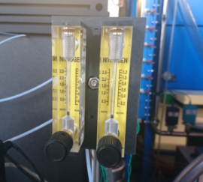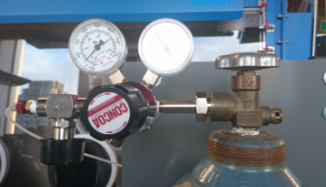

**Figure 19.** The N2 regulator and the flow meter.

**Parameters for the solvent reformatting**

The measurement parameters of the solvent reformatting are specified in the

*optical_characterizaitons/configs/* *config_AutoOpt_ocean.py*

You can change them by modifying the values in the file.

* **evaporation_temparature**: set temperature for the evaporation (in Celsius).
* **evaporation_time**: duration for the evaporation (in seconds).
* **dissolution_temparature**: set temperature for the re-dissolution (in Celsius).
* **shaking_speed**: shaking speed for the re-dissolution (0 to 9)
* **dissolution_time**: duration for the re-dissolution (in seconds).
* **solvent_volume**: solvent volume used for the re-dissolution (in mL).
* **idling_temparature**: set temperature for the idling state (in Celsius).
* **N_parallel**: the system starts solvent reformatting when this number of samples are collected in the collecton vials (only for auto_measurement with HPLCMS).
* **waiting_timeou**t: the system starts solvent reformatting even though the number of samples are not reached to the “N_parallel” when the time after the previous sample collection reaches this value (in seconds).

**Notes**

* The time and temperature necessary for the evaporation and re-dissolution process varies depends on the solvent and the sample. You will see the unstable baseline of the absorption spectrum if the evaporation is not completed or the sample is not fully dissolved in the solvent.

**4. Advanced usage**

**4-1. Developing a new workflow**

You can develop your own measurement workflow by using the low-level APIs that has functions to controls each component of the system. You can find these APIs in

“*Dropbox/PythonLab/pylab/instruments”*

You might also want to use the functions from the following scripts.

*“Dropbox/PythonScript/kazu/optical_characterizaitons/* *absorption_and_PL_ocean.py”*

*“Dropbox/PythonScript/kazu/optical_characterizaitons/* *transient_emission.py”*

The easiest way would be to define the new workflow as a function of the *Optical_measurements* class in the *Auto_opt_measurements_ocean.py.* **Do not forget to back up the original file** when you modify the script.

**Notes**

* It is also possible to add functions to those low-level APIs, however, you should be very careful as it can affect all the scripts that uses the API. I will recommend to back up the original file when you do that.
* The 6-port valve is usually set in the position where the syringe pump is connected to the flow selector, however, the tubing between the valve and the selector have a HPLC-MS solvent (i.e., mixture of water and acetonitrile) after the valve is switched for the sample collection from the HPLC-MS. This could cause the problems in the measurement such as the unstable baseline if you draw them to the syringe pump. So, you should be careful about this and do not forget to discard them to the waste before drawing or dispensing the solutions through the tubing when you develop your own workflow.

**4-2. Changing the configuration**

When you change the configuration of the setup (e.g., adding a new setup, changing the tube connection, etc.…), you have to specify them in the *Auto_opt_measurements_ocean.py*.

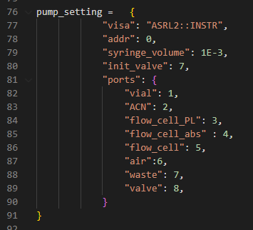 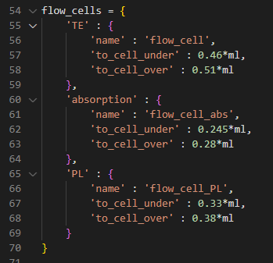

**Figure 20.** The setup configuration specified in the *Auto_opt_measurements_ocean.py*.

(left) The pump and (right) the flow cell configurations.

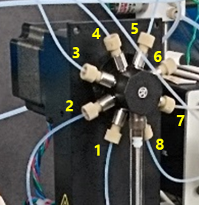

* pump_setting:

- init_valve: The pump is initialized at this valve position.

- ports: The map of the port name and the valve position.

(right figure)

* flow_cells: dictionary of the flow cells connected to the pump.
* name*: The name of the flow cell. It should correspond to the port name specified in the pump_setting.
* to_cell_under: the solution volume from the pump to the inlet of the flow cell.
* to_cell_over: the solution volume from the pump to the outlet of the flow cell.

The solution volume from the pump to the specific cell can be measured by using the *measure_line* function of the *Optical_measurements* class. See the example code in the *optical_measurement.py* for detail.



*The standard workflow is written using these cell names. You also have to change the cell names in the measurement functions if you change them in the configuration.

**4-3. Addition of new setups**

You might want to add the new setup to the system. Unfortunately, all the ports of the current syringe pump are in use, and thus you need to replace it with the pump with more ports or install additional pump to the system. The latter option could be done by connecting the new pump via the dilution vial (Fig. 21)

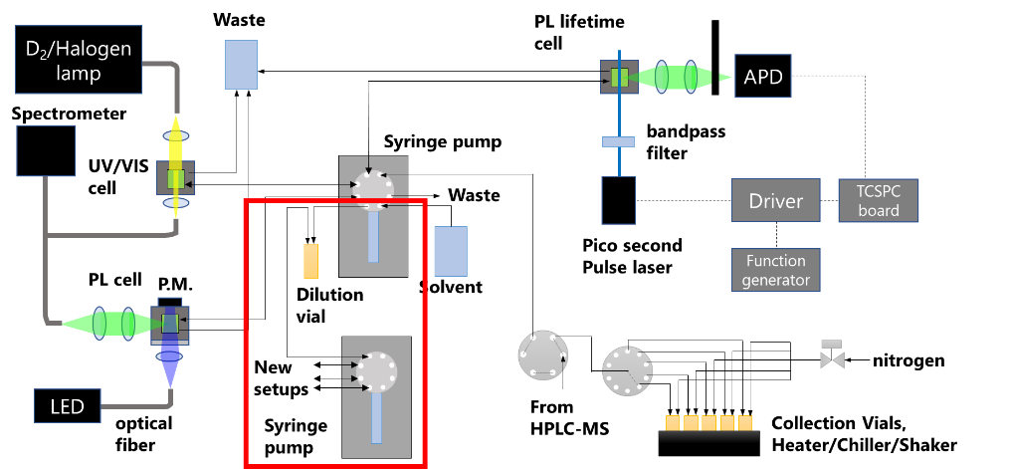

.

**Figure 21.** The possible connection for the additional syringe pump.

Software-wise, it would be easiest to define the measurement workflow of the new setup in the *Auto_opt_measurements_ocean.py* as a function and add it as the new type of the measurement in the *do_measurements* function.

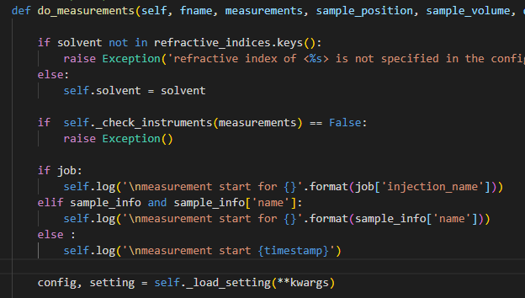

**:**

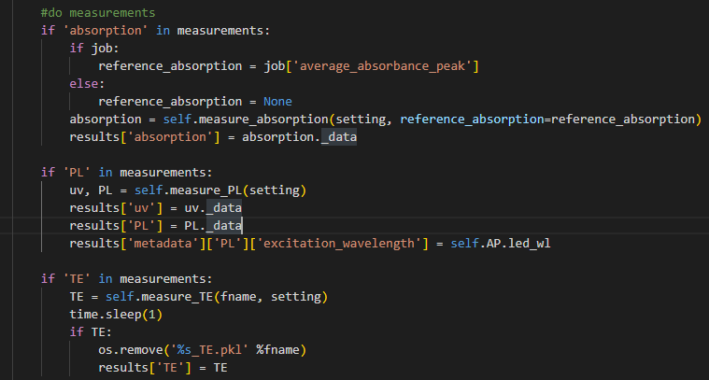

**Add new measurements here.**

**5. Maintenance**

**5-1. Calibration of the Spectrometer**

The spectrometer of the setup is calibrated using the standard fluorescence dyes (BAM-F002b to BAM-005b, Sigma Aldrich 75255-1KT). You have to recalibrated it when you change the optical configuration of the PL setup.

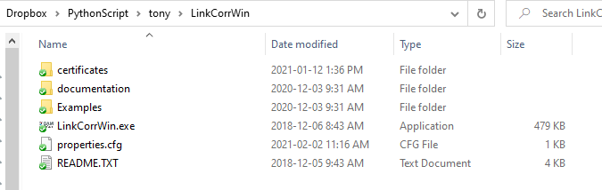

The SOP and the other documents as well as the software used for the calibration is in the above Dropbox folder. Follow the instructions in these documents. (The LEDs necessary for the excitation of the standard dyes are in the drawer besides the optical table.)

Once you obtained the calibration curve using the kit, locate the calibration file in the Dropbox folder and specified them in the configuration file (*config_AutoOpt_ocean.py*).

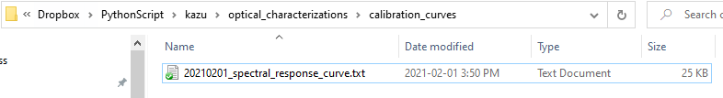

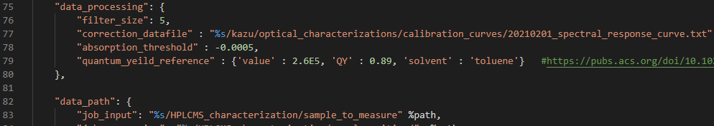

Notes:

* The calibration is only done in the spectral range **from 360 nm to 765 nm**. You should be careful about the fluorescence data out this range.
* The calibration using this kit is done against the **photon radiance**. The y-axis of the calibrated emission spectrum has a **photon unit (not energy)**.

**5-2. System washing**

The system can be washed with the solvent using the following commands.



* **Wash flow cells**

*Opt.cell_wash*

**Parameters**

* + **cells**: list of the flow cells to be washed.
  + **volume**: solvent volume used for the washing (per repeat).
  + **repeat**: number of washing to be done.
* **Wash dilution vial**

*Opt.vial_wash*

**Parameters**

* + **volume**: solvent volume used for the washing (per repeat).
  + **repeat**: number of washing to be done.
  + **fill**: vial is filled with the solvent after washing if True
* **Wash collector vials**

*Opt.collector_wash*

**Parameters**

* + **volume**: solvent volume used for the washing (per repeat).
  + **repeat**: number of washing to be done.
  + **collector_nums**: list of collector numbers to be washed.
  + **fill**: vial is filled with the solvent after washing if True

The flow cells are filled with the solvent after washing. If you want to fill the dilution vial and collector vials as well, you can do it by wash them with *fill = True*.

**6. Appendix**

**6-1. Parts list**

**6-1-1. Sample collector and transfer units**

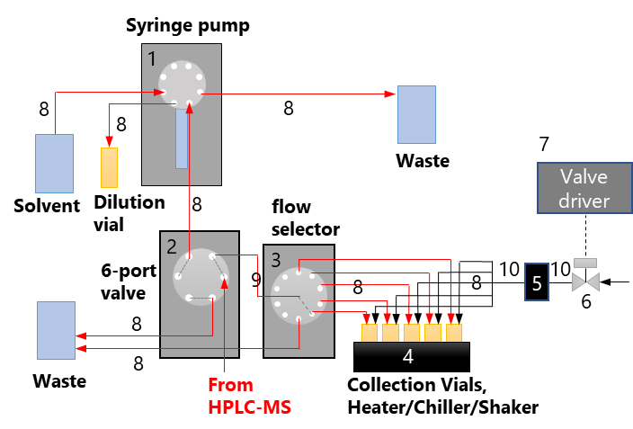

|  |  |  |  |  |
| --- | --- | --- | --- | --- |
|  | **Parts** | **Vender** | **Parts No.** | **Notes** |
| 1 | Syringe pump | Hamilton | PSD8 |  |
| 2 | 6-port valve | VICI | H-EUDB-C6W |  |
| 3 | Flow selector | VICI | H-C5H-2000EUHB |  |
| 4 | Heater/Chiller/Shaker | Torrey Pines | SC20XR |  |
| 5 | Flow meter | Dakota | 6A0105BV-NC |  |
| 6 | Solenoid valve | Cole Parmer | OF-01356-10 |  |
| 7 | Valve driver  (USB relay + circuit) | Numato lab | USBPOWRL004 |  |
| 8 | PTFE tubing | SUPELCO | 58696-U | O.D. 1.58 mm, I.D. 0.8 mm |
| 9 | PTFE tubing | SUPELCO | 58701 | O.D. 1.58 mm, I.D. 0.5 mm |
| 10 | PTFE tubing | SUPELCO | 58703 | O.D. 3.2 mm, I.D. 1.5 mm |
|  | Adaptor (Flow meter) | IDEX | U-510 |  |
|  | Tube fitting | IDEX | XP-235X |  |
|  | Tube fitting | IDEX | F-331 |  |

**Table A-1** Parts list for the sample collector and transfer units.

**6-1-2. UV-vis absorption setup**

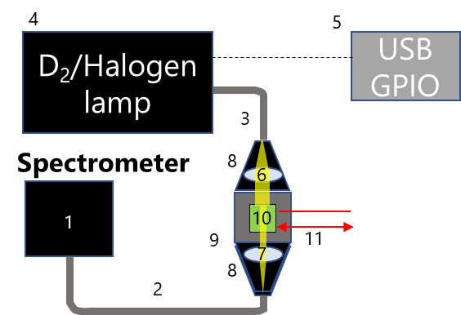

|  |  |  |  |  |
| --- | --- | --- | --- | --- |
|  | **Parts** | **Vender** | **Parts No.** | **Notes** |
| 1 | Spectrometer | Ocean Insight | QEPro XR |  |
| 2 | Optical fiber | Thorlabs | BFY600HS02 | Core diameter 600 um,  N.A. = 0.39, High-OH |
| 3 | Optical fiber | Thorlabs | M28L01 | Core diameter 600 um,  N.A. = 0.39, Low-OH,  (Better replace with high_OH) |
| 4 | D2/Halogen lamp | Ocean Insight | DH-MINI |  |
| 5 | Lamp control (USB GPIO) | Numato lab | GP80001 |  |
| 6 | Lens | Thorlabs | LA4647 | *f* = 20.1 mm, Ø1/2", Fused silica |
| 7 | Lens | Thorlabs | LA4647 | *f* = 20.1 mm, Ø1/2", Fused silica |
| 8 | Lens holder | Thorlabs | CVH100-COL |  |
| 9 | Cell holder | Thorlabs | CVH100 |  |
| 10 | Flow cell | Agilent | 0100-1224 | Path length 10 mm, volume 30 mL |
| 11 | FEP tube | Herma | 040-222-72 | O.D. 1.6 mm, I.D. 1.0 mm |

**Table A-2.** Parts list for the UV-vis absorption setup

**6-1-3. Photoluminescence setup**

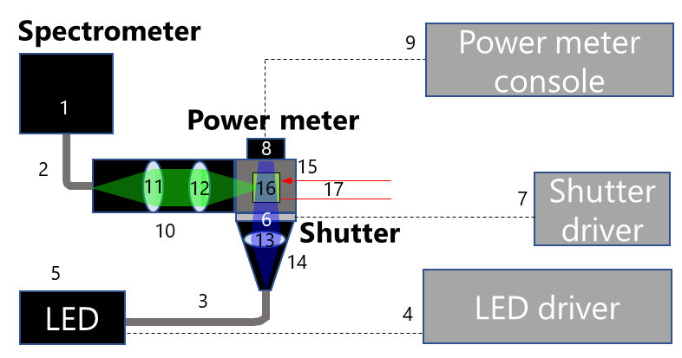

|  |  |  |  |  |
| --- | --- | --- | --- | --- |
|  | **Parts** | **Vender** | **Parts No.** | **Notes** |
| 1 | Spectrometer | Ocean Insight | QEPro XR |  |
| 2 | Optical fiber | Thorlabs | BFY600HS02 | Core diameter 600 um, N.A. = 0.39 |
| 3 | Optical fiber | Thorlabs | BF19Y2HS02 | Core diameter 200 um, N.A. = 0.22  (better replace with BFY600HS02) |
| 4 | LED driver | Thorlabs | DC4100, DC4100HUB |  |
| 5 | LED | Thorlabs | M365FP1 | lem = 365 nm (also have M300F2, M415F3, M530F2) |
| 6 | Shutter | Thorlabs | SH1 |  |
| 7 | Shutter driver | Thorlabs | KSC101 |  |
| 8 | Power meter | Thorlabs | S120VC | 50 nW - 50 mW, 200 nm-1100 nm |
| 9 | Power meter console | Thorlabs | PM100D |  |
| 10 | Lens tube | Thorlabs | SM05L20C |  |
| 11 | Lens | Thorlabs | AC127-025-A | *f* = 25.0 mm, Ø1/2", achromatic |
| 12 | Lens | Thorlabs | AC127-025-A | *f* = 25.0 mm, Ø1/2", achromatic |
| 13 | Lens | Thorlabs | LB1092-A | *f* = 15.0 mm, Ø1/2", N-BK7 |
| 14 | Lens holder | Thorlabs | CVH100-COL |  |
| 15 | Cell holder | Thorlabs | CVH100 |  |
| 16 | Flow cell | Herma | 176-762-85-40 | Path length 1.5x3.0 mm, volume 50mL |
| 17 | FEP tube | Herma | 040-222-72 | O.D. 1.6 mm, I.D. 1.0 mm |

**Table A-3.** Parts list for the PL setup

**6-1-4. PL lifetime setup**

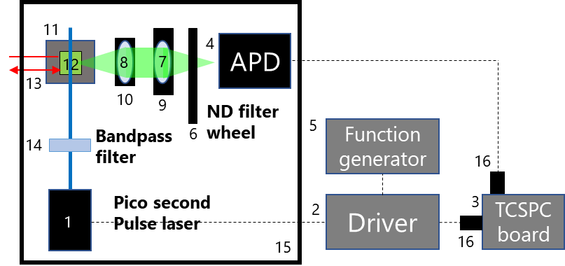

|  |  |  |  |  |
| --- | --- | --- | --- | --- |
|  | **Parts** | **Vender** | **Parts No.** | **Notes** |
| 1 | Laser | Pico Quant | LDH-D-C-375 | Pulse < 40 ps (FWHM),  max 40MHz, Avg. power 4 mW |
| 2 | Laser driver | Pico Quant | PDL 800-D |  |
| 3 | TCSPC board | Pico Quant | TimeHarp 260 |  |
| 4 | Avalanche photo diode | Micro photon divice | PDM |  |
| 5 | Function generator | Pico Technology | 5242D | 0.025 Hz to 20 MHz |
| 6 | ND filter wheel | Thorlabs | FW212CNEB |  |
| 7 | Lens | Thorlabs | LA1027-A | *f* = 35.0 mm, Ø1", N-BK7 |
| 8 | Lens | Thorlabs | LA4052-UV | *f* = 35.0 mm, Ø1", Fused silica |
| 9 | Lens holder | Thorlabs | CXYZ1 |  |
| 10 | Lens holder | Thorlabs | LMR1 |  |
| 11 | Cell holder | Thorlabs | CVH100 |  |
| 12 | Flow cell | Herma | 176-762-85-40 | Path length 1.5x3.0 mm, volume 50mL |
| 13 | FEP tube | Herma | 040-222-72 | O.D. 1.6 mm, I.D. 1.0 mm |
| 14 | Band pass filter | Edmonds optics | #86-732 | 375 nm, OD 4, 10 nm bandpass |
| 15 | Enclosure | Thorlabs | XE25C7 |  |
| 16 | Attenuator |  |  | 10 dB |

**Table A-4.** Parts list for the PL lifetime setup

**6-2. Trouble shooting**

|  |  |
| --- | --- |
|  |  |
| The pulse laser doesn’t emit the laser light. | Check if the limit switch for the interlock properly switched by the rid of enclosure. |
| The ND filter wheel doesn’t work. | Restart the python code. Sometimes it works by changing the USB port. |
| The syringe pump stops during the experiment. | Unplug and plug the power cable to restart the pump. Then, restart the python code. |
| The python code stops with an error at the initialization step. | Check all the devices necessary for the measurement are connected and power-on. |
| A baseline of absorption spectrum is not stable or goes away from 0. | Wait until the lamp and the spectrometer get stable. |
| Check if the solvent composition of the sample is the same as that of the reference solvent. |
| Check if the D2 and Halogen lamp is on (by checking the spectrum). Purchase and replace the bulb, if not. |

**6-3. Future Extensions**

* Installation of a solvent switching valve to use different solvent without manual operation.
* Installation of the individual solenoid valve for parallelization of solvent reformatting.
* Addition of the spec-echem setup.
* Addition of the laser gain measurement.
* Addition of the automated film fabricator.